# Impact of COVID on residential real estate in urban India

*Dr. Narayana, Professor, AIML, Anwesh, AIML Staff, Aakash****,*** *AIML Student, Arati****,*** *AIML Student, Anitha****,*** *AIML Student, Dilip****,*** *AIML Student, Sarang****,*** *AIML Student, Naresh****,*** *AIML Student.*

# Abstract

## Purpose

The purpose of this article is to explore the impact of COVID-19 on residential real estate for urban India. The study would cover the following

1. Valuation post COVID
2. COVID stabilization in metros
3. Public opinion on real estate investment

## Materials and methods

### Valuation post COVID

Statistical analysis would be conducted to check if there is a difference in valuation of properties before and after COVID and if the demand would still be as it was before.

The article covers the analysis of the following

* Area wise statistical analysis using two sample T test for real estate pricing before and after COVID for each of the identified cities for the same areas.
* Past data used for analysis has been sourced from websites / government registration data and kaggle for metros.
* Current data of prevailing market prices used for analysis are taken from the website for advertising residential properties

### COVID stabilization in metros

SIR is a model that is widely used by various analysts to estimate the peak and recovery. Model focuses on establishing the COVID curve for different states in India to see when the peak is expected to reach and when the curve would taper down, or at which point the country would reach a stage of herd immunity.

The actual infected and recovered data was available from the government sources for the period 14th March 2020 to 17th July 2020. Date till 11th July was used for building the SIR model. This data was used to estimate the beta and gamma that was prevalent during the entire period. The data 11th July to 17th July was considered for validating the model.

### Public opinion on real estate investment

A survey to analyse the market sentiments about real estate in India after covid-19 pandemic was conducted. Major cities like Mumbai, Pune, Delhi, Chennai, Bengaluru and Hyderabad were considered for the survey. People from these cities participated in the survey.

Inferences about market sentiments in major Indian cities are drawn based on peoples’ perception of the residential real estate market.

## Results

### Residential Real Estate price change summary

|  |  |  |  |
| --- | --- | --- | --- |
| **City** | **Increase** | **Decrease** | **No difference** |
| Bengaluru |  | 5 | 6 |
| Chennai |  | 5 | 2 |
| Delhi |  | 5 | 1 |
| Hyderabad | 2 | 1 | 6 |
| Mumbai | 6 |  | 11 |

### COVID summary city-wise

|  |  |  |  |  |  |  |  |  |
| --- | --- | --- | --- | --- | --- | --- | --- | --- |
| **City** | **Population**  **In million** | **City % over state** | **% Infected** | **Infection Peak** | **Peak date** | **Infected** | | |
| **@100th day** | **@200th day** | **@300th day** |
| **Bengaluru** | 12.327 | 50% | 3 | **120,312** | **12.09.2020** | 5,482 | 108,020 | 14,804 |
| 5 | **202,202** | **22.09.2020** | 5,418 | 197,470 | 32,320 |
| **Chennai** | 10.971 | 53% | 3 | **103,110** | **04.08.2020** | 35,155 | 43,261 | 3,573 |
| 5 | **157,024** | **16.08.2020** | 31,388 | 87,978 | 7,570 |
| **Delhi** | 19.298 | 100% | 3 | **159,652** | **05.08.2020** | 63,531 | 75,670 | 6,920 |
| 5 | **240,493** | **16.08.2020** | 60,453 | 139,246 | 12,393 |
| **Hyderabad** | 10.000 | 75% | 3 | **84,356** | **25.08.2020** | 8,296 | 53,165 | 3,872 |
| 5 | **127,794** | **02.09.2020** | 8,157 | 93,508 | 6,533 |
| **Mumbai** | 20.411 | 34% | 3 | **198,348** | **26.08.2020** | 42,423 | 152,942 | 26,680 |
| 5 | **317,165** | **08.09.2020** | 41,359 | 282,760 | 54,765 |

### COVID summary city-wise

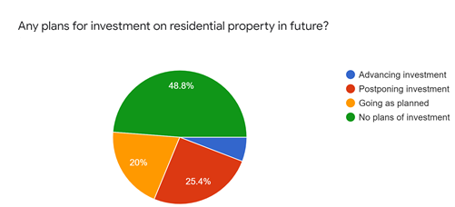

## Conclusion

It would be tough months ahead for residential real estate industry, with COVID continuing till last quarter well beyond festival season with sizeable number of people planning to postpone their investment plans.

* Immediate effect of COVID is seen in the residential real estate industry. Around 35% of the areas considered which represented urban India had decreased valuation of real estate while the other 60% was just stable without much significant difference. Only 5% of the areas saw value increasing.
* The pandemic would be at its peak between mid-August to mid-September 2020 with all the major cities touching 1 to 2 lakh active cases.
* A large percentage of the people who participated in the survey expect that the real estate prices would come down because of the pandemic and a significant portion of the people are uncertain to get into new real estate transactions because of uncertain economic stability and job insecurity. Around 30% to 40% of the people have changed their plans of buying a residential real estate property.

# Project Insights

## Valuation post COVID:

The Indian real estate market was already going through prolonged pain for various reasons such as economic stress in certain segments, high leverage, tight liquidity and rising non-performing assets (NPAs) in construction finance. While the government announced incentives for affordable housing by various means, they coincided with the current world’s deepest crisis. Real estate markets may crash upto 20% is what analysts predict. [9]

In this article, analysis would be conducted to check if there is a difference in valuation of properties before and after COVID and if the demand would still be as it was before. The article covers the analysis of the following

* *Area wise statistical analysis using two sample T test for real estate pricing before and after COVID for each of the identified cities for the same areas.*
* *Past data used for analysis has been sourced from websites / government registration data and kaggle for metros*
* *Current data of prevailing market prices used for analysis are taken from the website for advertising residential properties*

### Cities and areas

Cities / areas were selected for different metros across India so that a true picture of the whole country's metropolitan areas can be derived. Popular real estate areas in the cities were chosen which represent the trends.

List of areas and cities are cited in the below table.

|  |  |  |  |  |
| --- | --- | --- | --- | --- |
| **Bengaluru** | **Chennai** | **Delhi** | **Hyderabad** | **Mumbai** |
| * Koramangala * Indiranagar * HSR Layout * BTM Layout * Sarjapur * Whitefield * Marathahalli * Bellandur * Yelahanka * Hebbal * Electronic City | * Adyar * Anna Nagar * Chromepet * Karapakkam * KK Nagar * T Nagar * Velachery | * Alaknanda * CommonWealth Games village * Dilshad Garden * Chhattarpur * Vasundhara enclave * Sarita Vihar | * Gachibowli * Hitech City * Kondapur * Banjara Hills * Jubilee Hills * Miyapur * Manikonda * Madhapur * Serilingampally | * Andheri East * Bandra West * Borivali West * Dadar East * Dadar West * Dombivli West * Mahalaxmi * Powai * Ambernath East * Worli * Juhu |

### Data collection

#### Data for 2019:

The 2019 data was collected using different sources for different cities. After the collection, the data was validated with the reference data available from PropTiger for each city and area. The method used for collecting data is documented in the table below.

|  |  |
| --- | --- |
| **City** | **Method** |
| Bengaluru | 2018 data was available in Kaggle. Using this data as base and the appreciation data available in Magic bricks property trends a model was developed to build the 2019 proxy data. |
| Chennai | Data was available in Kaggle for 2005 till 2015. Using this data as base and the appreciation data available in Magic bricks property trends a model was developed to build the 2019 proxy data. |
| Delhi | 2019 data was directly available in Kaggle and the same was used for analysis. |
| Hyderabad | 2019 scrapped data was available in GitHub and the same was used |
| Mumbai | 2019 data was scraped from Makaan.com with old pages pre-covid |

#### Data for 2020:

* Data was scraped from website makaan.com
* Data from prop tiger was used to assess the data ranges and validate the quality of data
* In case where the proxy data was built for 2019 based on previous years data, a 10% tone down was done for the prices per square feet for 2020 data which was advertisement prices.

### Statistical model development

T-test is a type of inferential statistic used to determine if there is a significant difference between the means of two groups, which may be related to certain features. The t-test is one of many tests used for the purpose of hypothesis testing in statistics.

Area wise statistical analysis using two sample T- test for real estate pricing before and after COVID for each of the identified cities for the same areas were performed and the results of TStat and Alpha were analysed to see if there was significant difference.

### Inference

The table indicates the results of T-Test and summarises the valuation variation of the areas in each city. The inferences are based on the results summarised in the **Results of T-test for the different areas in each city**.

|  |  |  |  |
| --- | --- | --- | --- |
| **City** | **Number of Locations** | | |
| **Increase** | **Decrease** | **No difference** |
| Bengaluru |  | 5 | 6 |
| Chennai |  | 5 | 2 |
| Delhi |  | 5 | 1 |
| Hyderabad | 2 | 1 | 6 |
| Mumbai | 6 |  | 11 |

### Results of T-test for the different areas in each city

#### Bengaluru

|  |  |  |  |  |
| --- | --- | --- | --- | --- |
| **Location** | **Increased** | **Decreased** | **No Significant Difference** | **Avg % Increase over 2019** |
| Koramangala |  |  | X | -6.36 |
| Indiranagar |  | X |  | -28.19 |
| HSR Layout |  |  | X | -15.08 |
| BTM Layout |  |  | X | -16.32 |
| Sarjapur |  |  | X | -11.92 |
| Whitefield |  |  | X | -23.13 |
| Marathahalli |  | X |  | -21.85 |
| Bellandur |  | X |  | -7.56 |
| Yelahanka |  | X |  | -25.46 |
| Hebbal |  |  | X | -26.87 |
| Electronic City |  | X |  | -16.96 |

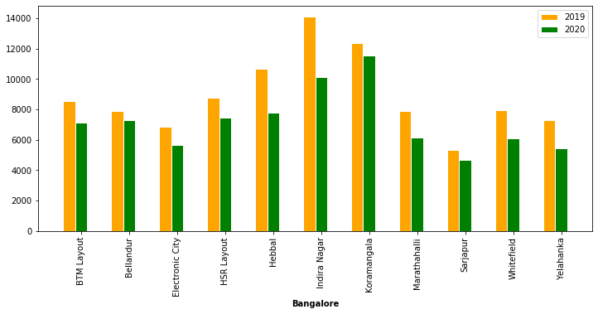

#### Chennai

|  |  |  |  |  |
| --- | --- | --- | --- | --- |
| **Location** | **Increased** | **Decreased** | **No Significant Difference** | **Avg % Increase over 2019** |
| Adyar |  | X |  | -12.40 |
| Anna Nagar |  |  | X | 0.70 |
| Chromepet |  | X |  | -55.80 |
| Karapakkam |  | X |  | 2.30 |
| KK Nagar |  | X |  | -44.20 |
| T Nagar |  |  | X | 1.50 |
| Velachery |  | X |  | -21.00 |

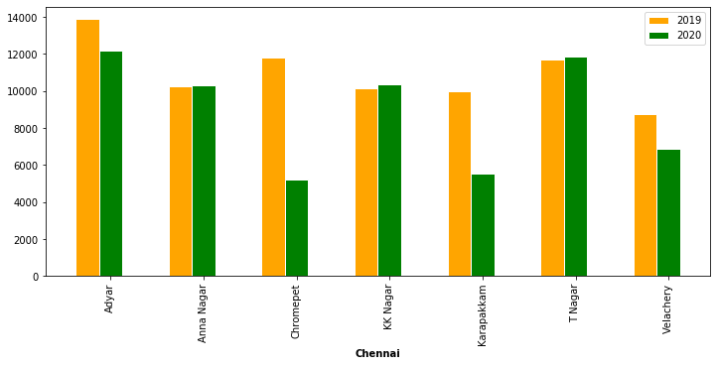

#### Delhi

|  |  |  |  |  |
| --- | --- | --- | --- | --- |
| **Location** | **Increased** | **Decreased** | **No Significant Difference** | **Avg % Increase over 2019** |
| Alaknanda |  | X |  | -5.00 |
| CommonWealth Games village |  | X |  | -8.90 |
| Dilshad Garden |  |  | X | 7.67 |
| Chhattarpur |  | X |  | -7.00 |
| Vasundhara enclave |  | X |  | -4.30 |
| Sarita Vihar |  | X |  | -27.70 |

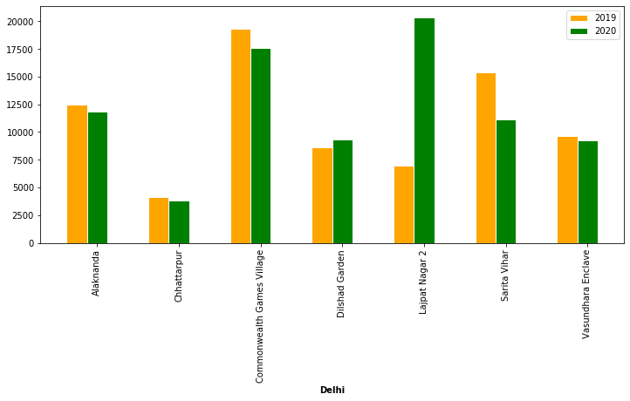

#### Hyderabad

|  |  |  |  |  |
| --- | --- | --- | --- | --- |
| **Location** | **Increased** | **Decreased** | **No Significant Difference** | **Avg % Increase over 2019** |
| Banjara Hills |  |  | X | -0.369 |
| Gachibowli | X |  |  | 17.30 |
| Hitech City | X |  |  | 12.30 |
| Jubilee Hills |  |  | X | 8.10 |
| Kondapur |  |  | X | 6.757 |
| Madhapur |  |  | X | 0.86 |
| Manikonda |  |  | X | 7.52 |
| Miyapur |  | X |  | -13.00 |
| Serilingampally |  |  | X | 7.34 |

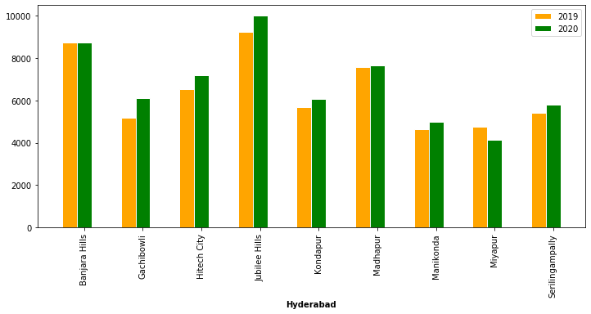

#### Mumbai

|  |  |  |  |  |
| --- | --- | --- | --- | --- |
| **Location** | **Increased** | **Decreased** | **No Significant Difference** | **Avg % Increase over 2019** |
| Andheri East |  |  | X | -12.83 |
| Bandra West |  |  | X | -1.98 |
| Borivali West |  |  | X | -3.82 |
| Dadar East |  |  | X | 3.87 |
| Dadar West |  |  | X | -5.59 |
| Dombivli West |  |  | X | 28.45 |
| Mahalaxmi |  |  | X | 4.81 |
| Powai |  |  | X | 7.87 |
| Ambernath East |  |  | X | -0.06 |
| Worli |  |  | X | -9.86 |
| Juhu |  |  | X | -15.85 |

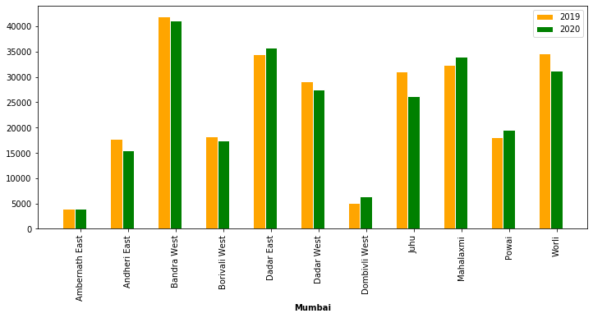

## COVID stabilization in metros

SIR is a model that is widely used by various analysts to estimate the peak and recovery. The SIR model is a kind of compartmental model describing the dynamics of infectious disease. The model divides the population into compartments. Each compartment is expected to have the same characteristics. SIR represents the three compartments segmented by the model.  [12][[13]](https://docs.google.com/document/d/1lKRZMRQfBba7bsp8ujkL5BXrcaxeH2wm029WUoriAsQ/edit#bookmark=id.sqljlrmbozch)[[14]](https://docs.google.com/document/d/1lKRZMRQfBba7bsp8ujkL5BXrcaxeH2wm029WUoriAsQ/edit#bookmark=id.euhea1zjbq7)

• Susceptible

• Infectious

• Recovered

Model focuses on establishing the COVID curve for different states in India to see when the peak is expected to reach and when the curve would taper down or at which point the country would reach a stage of herd immunity.

Based on this model, the estimation of COVID stabilization trend for the country done by data analysts indicates that it might take close to 150 - 200 days. [[15]](https://docs.google.com/document/d/1lKRZMRQfBba7bsp8ujkL5BXrcaxeH2wm029WUoriAsQ/edit#bookmark=id.oesgtikmn4fb)

This article uses the SIR model to predict the COVID curve stabilization for the following cities

* Bengaluru
* Chennai
* Delhi
* Hyderabad
* Mumbai

Based on the study results, we can visualize when the residential real estate industry would stabilize and transactions can happen seamlessly as in the past.

### The SIR epidemic model

SIR model is a simple mathematical model used to predict the spread of a disease in a population. IT divides the (fixed) population of N individuals into three "compartments" which may vary as a function of time, t:

* S(t) are those susceptible but not yet infected with the disease
* I(t) is the number of infectious individuals
* R(t) are those individuals who have recovered from the disease and now have immunity to it

The differential equations describing this model were first derived by Kermack and McKendrick [100].

The SIR model describes the change in the population of each of these compartments in terms of two parameters, β and γ.

* β describes the effective contact rate of the disease: an infected individual comes into contact with βN other individuals per unit time (of which the fraction that are susceptible to contracting the disease is S/N).
* γ is the mean recovery rate: that is, 1/γ is the mean period of time during which an infected individual can pass it on.

N is the total number of assumed population who are expected to get infected and this value is typically seen by experts for pandemics as 2% to 5%

* dS/dt = -beta * S * I / N
* dI/dt = beta * S * I/N - gamma * I
* dR/dt = gamma * I

### Prediction model for Urban India cities

The actual infected and recovered data was available from the government sources for the period 14th March 2020 to 17th July 2020. Date till 11th July was used for building the SIR model. This data was used to estimate the beta and gamma that was prevalent during the entire period. The data 11th July to 17th July was considered for validating the model.

City wise daily data was not available. Therefore, proxy data was built for each city except Delhi based on the state wise data. The percentage contribution from the city on 11th July 2020 was taken as the basis for building the proxy data [I, R].

The 25th percentile and 75th percentile values of beta and gamma taken from the actual data were then used to loop for a range of betas and gammas within. Using this beta and gamma the S, I, R were predicted and the mean square differences between the actual and the predicted were found for the available period until 11th July 2020. The model then used the beta and gamma that was with minimum MSE to estimate the S, I, R curve for the given city. The same procedure was done with 3% as potential infected and 5% as potential infected.

The approach was used for different cities and the results available in the table below.

|  |  |  |  |  |  |  |  |  |
| --- | --- | --- | --- | --- | --- | --- | --- | --- |
| **City** | **Population**  **In million** | **City % over state** | **% Infected** | **Infection Peak** | **Peak date** | **Infected** | | |
| **@100th day** | **@200th day** | **@300th day** |
| **Bengaluru** | 12.327 | 50% | 3 | **120,312** | **12.09.2020** | 5,482 | 108,020 | 14,804 |
| 5 | **202,202** | **22.09.2020** | 5,418 | 197,470 | 32,320 |
| **Chennai** | 10.971 | 53% | 3 | **103,110** | **04.08.2020** | 35,155 | 43,261 | 3,573 |
| 5 | **157,024** | **16.08.2020** | 31,388 | 87,978 | 7,570 |
| **Delhi** | 19.298 | 100% | 3 | **159,652** | **05.08.2020** | 63,531 | 75,670 | 6,920 |
| 5 | **240,493** | **16.08.2020** | 60,453 | 139,246 | 12,393 |
| **Hyderabad** | 10.000 | 75% | 3 | **84,356** | **25.08.2020** | 8,296 | 53,165 | 3,872 |
| 5 | **127,794** | **02.09.2020** | 8,157 | 93,508 | 6,533 |
| **Mumbai** | 20.411 | 34% | 3 | **198,348** | **26.08.2020** | 42,423 | 152,942 | 26,680 |
| 5 | **317,165** | **08.09.2020** | 41,359 | 282,760 | 54,765 |

### Estimated vs. Actual for 12.07.2020 to 17.07.2020

#### Bengaluru - 3%

|  |  |  |  |  |  |
| --- | --- | --- | --- | --- | --- |
| **Day** | **Date** | **Actual** | | **Predicted** | |
| **Infected** | **Removed** | **Infected** | **Removed** |
| 120 | 12-07-2020 | 19,375 | 8,030 | 17,488 | 8,359 |
| 121 | 13-07-2020 | 20,740 | 8,485 | 18,482 | 8,860 |
| 122 | 14-07-2020 | 21,986 | 9,098 | 19,524 | 9,390 |
| 123 | 15-07-2020 | 23,570 | 9,678 | 20,618 | 9,950 |
| 124 | 16-07-2020 | 25,650 | 10,360 | 21,764 | 10,541 |
| 125 | 17-07-2020 | 27,491 | 10,930 | 22,964 | 11,165 |

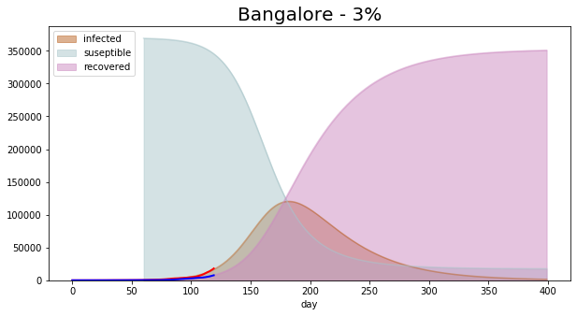

#### Bengaluru - 5%

|  |  |  |  |  |  |
| --- | --- | --- | --- | --- | --- |
| **Day** | **Date** | **Actual** | | **Predicted** | |
| **Infected** | **Removed** | **Infected** | **Removed** |
| 120 | 12-07-2020 | 19,375 | 8,030 | 17,613 | 8,152 |
| 121 | 13-07-2020 | 20,740 | 8,485 | 18,652 | 8,647 |
| 122 | 14-07-2020 | 21,986 | 9,098 | 19,747 | 9,172 |
| 123 | 15-07-2020 | 23,570 | 9,678 | 20,902 | 9,727 |
| 124 | 16-07-2020 | 25,650 | 10,360 | 22,119 | 10,315 |
| 125 | 17-07-2020 | 27,491 | 10,930 | 23,401 | 10,936 |

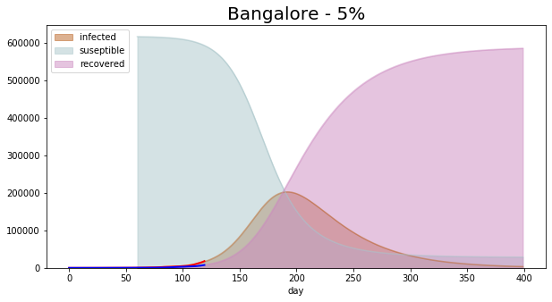

#### Chennai - 3%

|  |  |  |  |  |  |
| --- | --- | --- | --- | --- | --- |
| **Day** | **Date** | **Actual** | | **Predicted** | |
| **Infected** | **Removed** | **Infected** | **Removed** |
| 120 | 12-07-2020 | 73,389 | 48,494 | 77,144 | 53,636 |
| 121 | 13-07-2020 | 75,683 | 50,137 | 79,217 | 56,072 |
| 122 | 14-07-2020 | 78,082 | 52,687 | 81,238 | 58,572 |
| 123 | 15-07-2020 | 80,465 | 55,373 | 83,200 | 61,134 |
| 124 | 16-07-2020 | 82,876 | 58,116 | 85,096 | 63,757 |
| 125 | 17-07-2020 | 85,281 | 59,955 | 86,920 | 66,437 |

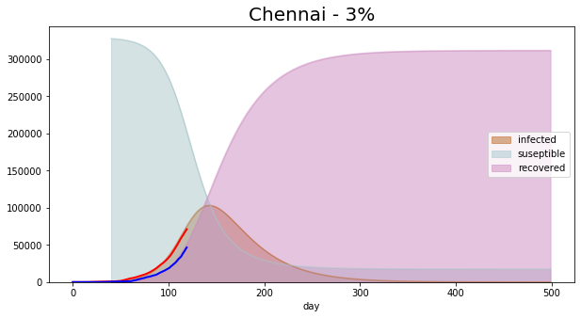

#### Chennai - 5%

|  |  |  |  |  |  |
| --- | --- | --- | --- | --- | --- |
| **Day** | **Date** | **Actual** | | **Predicted** | |
| **Infected** | **Removed** | **Infected** | **Removed** |
| 120 | 12-07-2020 | 73,389 | 48,494 | 78,639 | 50,888 |
| 121 | 13-07-2020 | 75,683 | 50,137 | 81,743 | 53,472 |
| 122 | 14-07-2020 | 78,082 | 52,687 | 84,886 | 56,157 |
| 123 | 15-07-2020 | 80,465 | 55,373 | 88,061 | 58,944 |
| 124 | 16-07-2020 | 82,876 | 58,116 | 91,261 | 61,833 |
| 125 | 17-07-2020 | 85,281 | 59,955 | 94,479 | 64,826 |

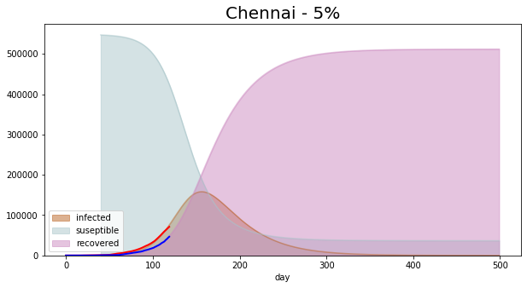

#### Delhi - 3%

|  |  |  |  |  |  |
| --- | --- | --- | --- | --- | --- |
| **Day** | **Date** | **Actual** | | **Predicted** | |
| **Infected** | **Removed** | **Infected** | **Removed** |
| 120 | 12-07-2020 | 1,38,470 | 91,498 | 1,24,809 | 98,568 |
| 121 | 13-07-2020 | 1,42,798 | 94,599 | 1,27,741 | 1,02,571 |
| 122 | 14-07-2020 | 1,47,324 | 99,409 | 1,30,600 | 1,06,666 |
| 123 | 15-07-2020 | 1,51,820 | 1,04,477 | 1,33,379 | 1,10,850 |
| 124 | 16-07-2020 | 1,56,369 | 1,09,652 | 1,36,069 | 1,15,120 |
| 125 | 17-07-2020 | 1,60,907 | 1,13,122 | 1,38,662 | 1,19,475 |

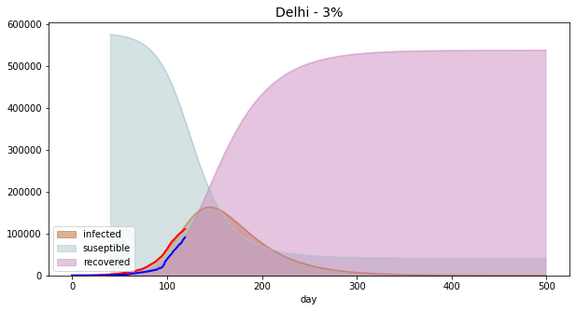

#### Delhi - 5%

|  |  |  |  |  |  |
| --- | --- | --- | --- | --- | --- |
| **Day** | **Date** | **Actual** | | **Predicted** | |
| **Infected** | **Removed** | **Infected** | **Removed** |
| 120 | 12-07-2020 | 1,12,494 | 93,339 | 1,35,868 | 1,06,611 |
| 121 | 13-07-2020 | 1,13,740 | 94,723 | 1,40,383 | 1,11,424 |
| 122 | 14-07-2020 | 1,15,346 | 96,682 | 1,44,920 | 1,16,395 |
| 123 | 15-07-2020 | 1,16,993 | 99,186 | 1,49,469 | 1,21,524 |
| 124 | 16-07-2020 | 1,18,645 | 1,01,238 | 1,54,018 | 1,26,812 |
| 125 | 17-07-2020 | 1,20,107 | 1,02,872 | 1,58,558 | 1,32,259 |

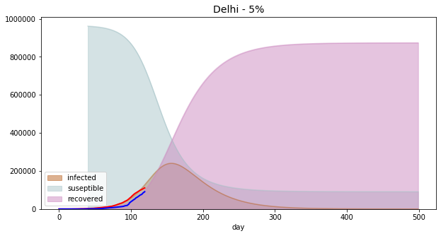

#### Hyderabad – 3%

|  |  |  |  |  |  |
| --- | --- | --- | --- | --- | --- |
| **Day** | **Date** | **Actual** | | **Predicted** | |
| **Infected** | **Removed** | **Infected** | **Removed** |
| 120 | 12-07-2020 | 26,003 | 17,128 | 26,114 | 16,030 |
| 121 | 13-07-2020 | 27,165 | 18,033 | 27,485 | 16,984 |
| 122 | 14-07-2020 | 28,308 | 18,911 | 28,906 | 17,988 |
| 123 | 15-07-2020 | 29,506 | 19,788 | 30,374 | 19,043 |
| 124 | 16-07-2020 | 30,763 | 20,768 | 31,890 | 20,152 |
| 125 | 17-07-2020 | 31,872 | 21,831 | 33,451 | 21,315 |

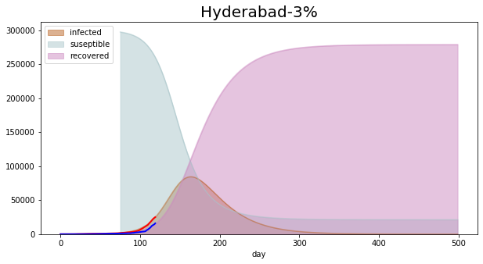

#### Hyderabad - 5%

|  |  |  |  |  |  |
| --- | --- | --- | --- | --- | --- |
| **Day** | **Date** | **Actual** | | **Predicted** | |
| **Infected** | **Removed** | **Infected** | **Removed** |
| 120 | 12-07-2020 | 26,003 | 17,128 | 26,543 | 17,299 |
| 121 | 13-07-2020 | 27,165 | 18,033 | 28,043 | 18,359 |
| 122 | 14-07-2020 | 28,308 | 18,911 | 29,613 | 19,479 |
| 123 | 15-07-2020 | 29,506 | 19,788 | 31,252 | 20,660 |
| 124 | 16-07-2020 | 30,763 | 20,768 | 32,963 | 21,907 |
| 125 | 17-07-2020 | 31,872 | 21,831 | 34,746 | 23,222 |

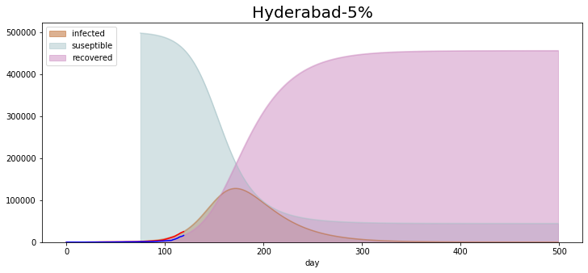

#### Mumbai - 3%

|  |  |  |  |  |  |
| --- | --- | --- | --- | --- | --- |
| **Day** | **Date** | **Actual** | | **Predicted** | |
| **Infected** | **Removed** | **Infected** | **Removed** |
| 120 | 12-07-2020 | 86,505 | 51,208 | 93,680 | 51,451 |
| 121 | 13-07-2020 | 88,714 | 52,696 | 96,887 | 53,706 |
| 122 | 14-07-2020 | 91,006 | 54,298 | 100,135 | 56,038 |
| 123 | 15-07-2020 | 93,718 | 55,604 | 103,421 | 58,447 |
| 124 | 16-07-2020 | 96,656 | 57,573 | 106,738 | 60,934 |
| 125 | 17-07-2020 | 99,480 | 58,415 | 110,083 | 63,499 |

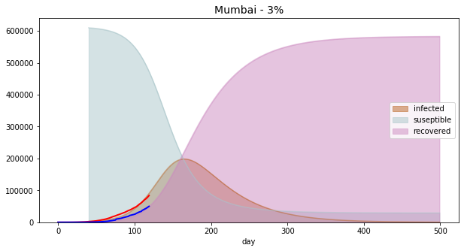

#### Mumbai - 5%

|  |  |  |  |  |  |
| --- | --- | --- | --- | --- | --- |
| **Day** | **Date** | **Actual** | | **Predicted** | |
| **Infected** | **Removed** | **Infected** | **Removed** |
| 120 | 12-07-2020 | 86,505 | 51,208 | 97,946 | 52,268 |
| 121 | 13-07-2020 | 88,714 | 52,696 | 101,864 | 54,689 |
| 122 | 14-07-2020 | 91,006 | 54,298 | 105,889 | 57,205 |
| 123 | 15-07-2020 | 93,718 | 55,604 | 110,019 | 59,820 |
| 124 | 16-07-2020 | 96,656 | 57,573 | 114,253 | 62,537 |
| 125 | 17-07-2020 | 99,480 | 58,415 | 118,589 | 65,357 |

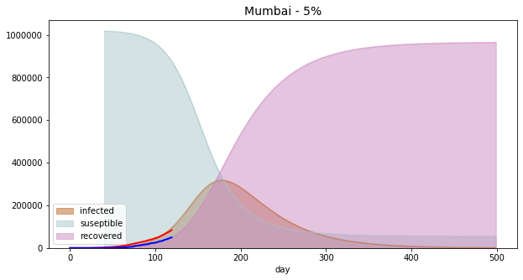

### Beta, Gamma, Mean square errors for I & R actual curves [until 11.07.2020]

#### Bengaluru

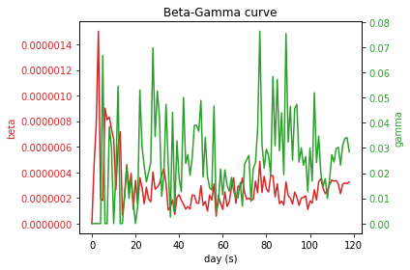

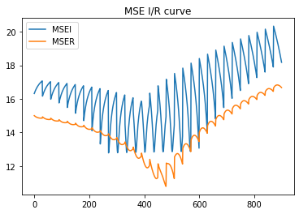

#### Chennai

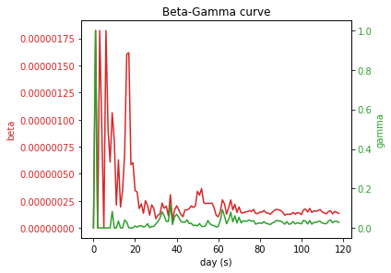

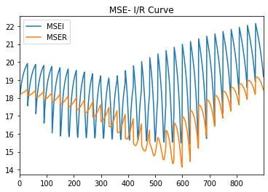

#### Delhi

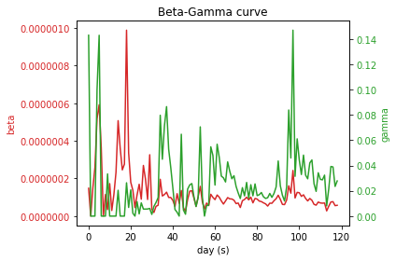

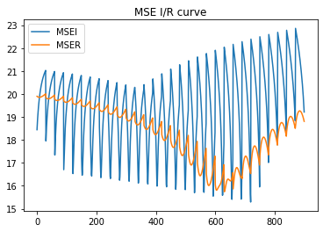

#### Hyderabad

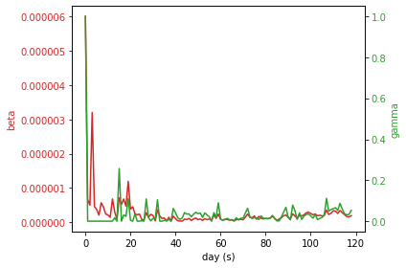

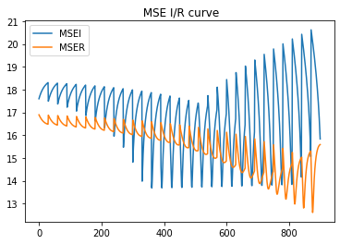

#### Mumbai

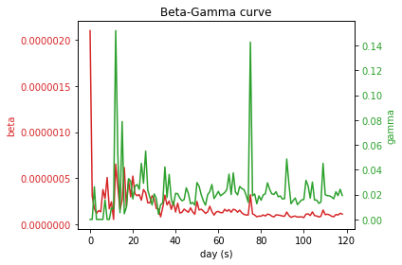

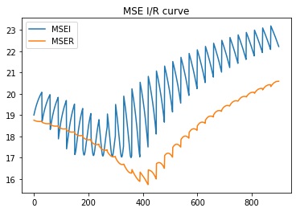

## Market Sentiments in Metros Post COVID-19

The Indian real estate sector had just started to recover from structural reforms such as demonetisation, Real Estate Regulatory Authority Act (RERA), Good and Services Tax (GST) and liquidity issues arising out of the NBFC crisis. Measures adopted by the government to help the sector, such as the AIF of INR 250 billion for completion of stalled projects were starting to infuse confidence in the sector. This was evident in the optimistic Sentiment Index Scores of the preceding quarter (Q4 2019). However, the sector is in severe crisis yet again as the revival of confidence has been dampened by the COVID 19 outbreak.

The survey was conducted to analyse the market sentiments about real estate in India after covid-19 pandemic. The targeted major cities were Mumbai, Pune, Delhi, Chennai, Bengaluru and Hyderabad.  People from these cities participated in the survey. Inferences were drawn based on the responses received.

### Sentiment Index Survey Findings:

* With people having pay cuts and job losses, low and mid- priced segment would be hit the most
* For the high-priced segments, the buying decision might get deferred due to the sharp wealth erosion and poor consumer sentiments
* Prices to see a dip in the weak demand scenario

The detailed inferences are listed below.

#### Inference 1

People across different age groups, income ranges and income source types think that real estate prices will decrease.

The perspective of people of different age groups, income source type and income ranges from the survey is given below

|  |  |  |  |
| --- | --- | --- | --- |
| **Employment Type** | **It will be stable** | **It will decrease** | **It will increase** |
| Business | 0% | 2% | 0% |
| Salaried | 25% | 50% | 16% |
| Self-Employed | 1% | 2% | 4% |
| **Grand Total** | **26%** | **54%** | **20%** |

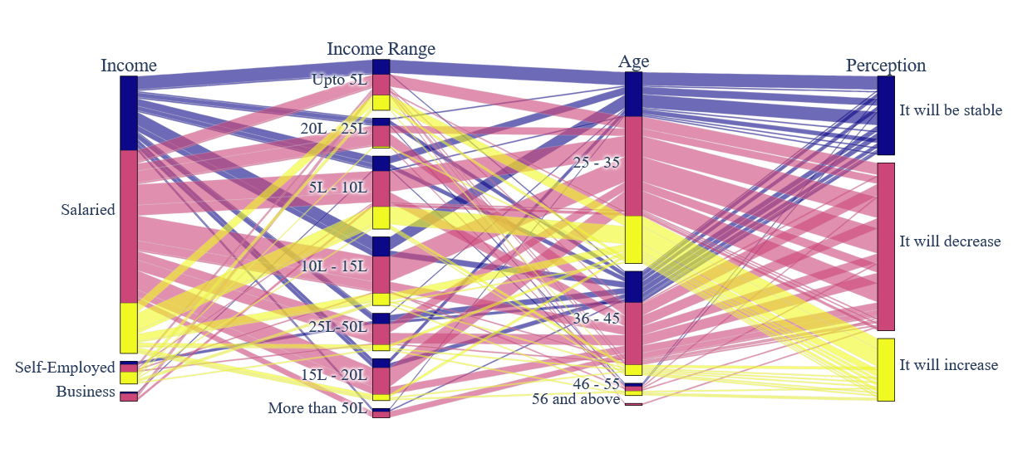

#### Inference 2

People who had plans of investing in the future, around 50% of them are postponing their decision of the investment.

Responses received, were from both residential property owners and non-owners and both of them have the same opinion as seen below

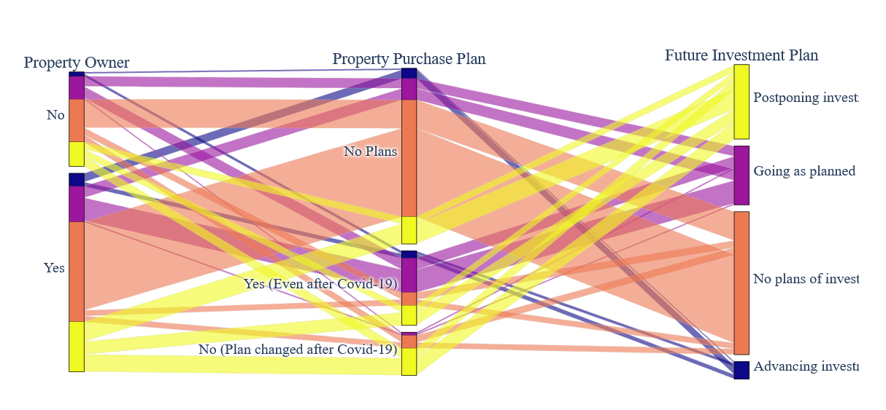

#### Inference 3

Investment plans have changed majorly because of uncertainty in economy and job insecurity.

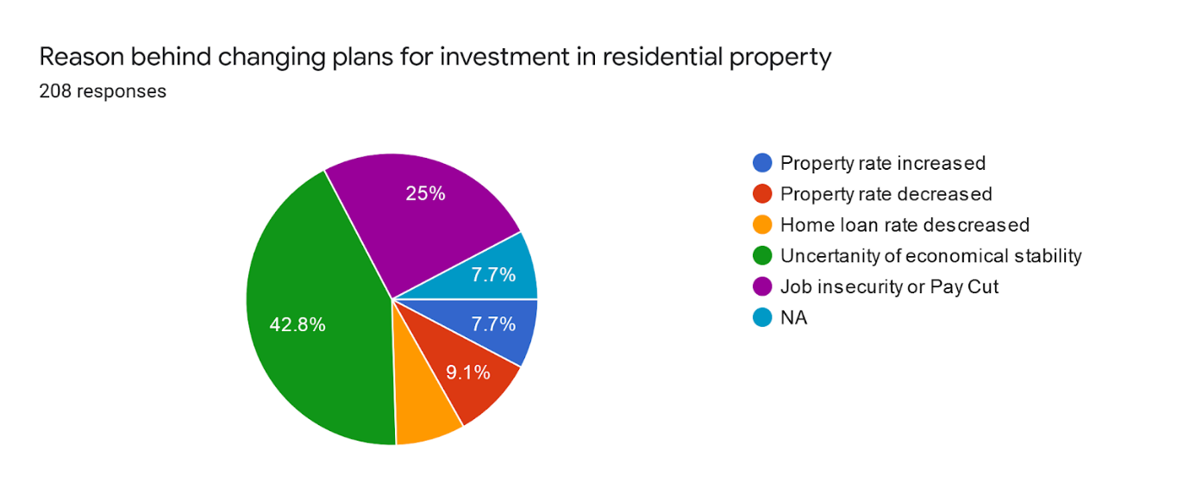

#### Inference 4

People want to cash in on the situation and are expecting builders to reduce rates, give offers and discounts along with providing quality layout and open space.

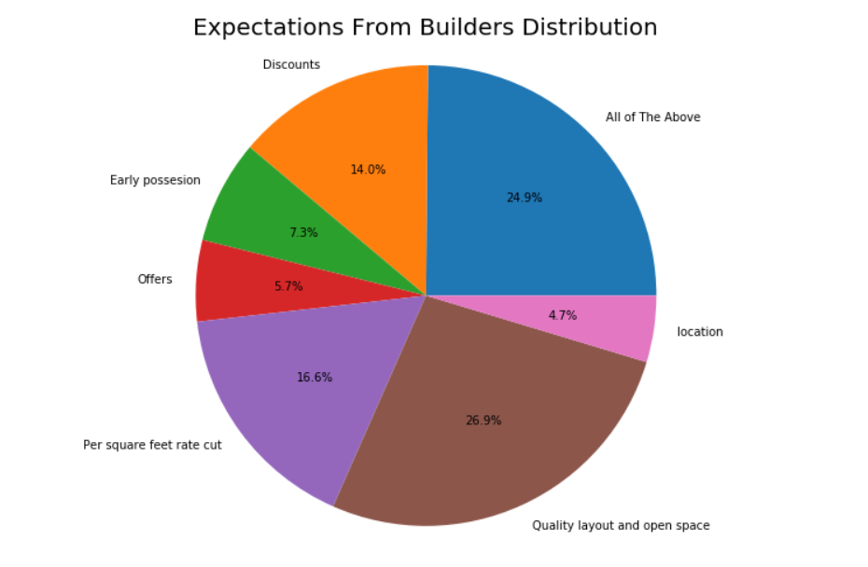

#### Inference 5

People entrust more the medium sized builders followed by big builders. There could be challenges for small sized builders

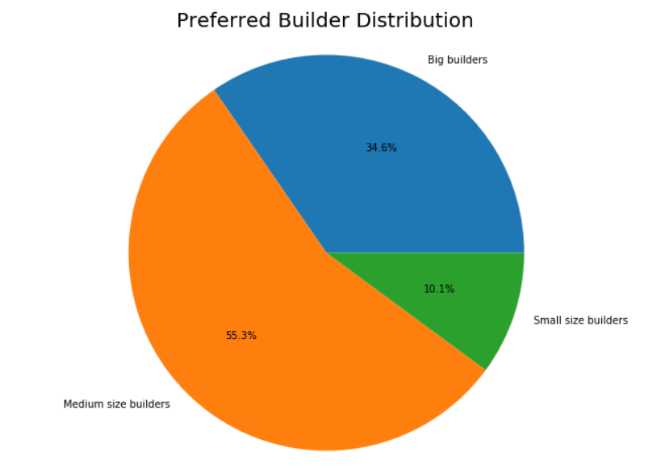

#### Inference 6

People are expecting the government to give relief by reducing GST, Service Tax, Interest Rate

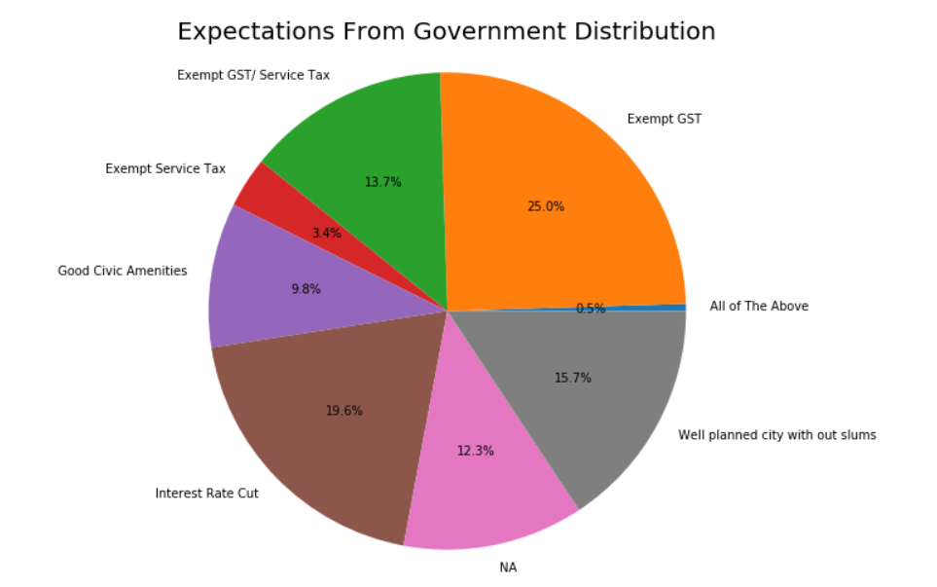

## References

|  |  |
| --- | --- |
| [1] | Disease Control Priorities: Improving Health and Reducing Poverty. 3rd edition, (27, November) 2017;  Jamison DT, Gelband H, Horton S, et al., editors  Online: [Chapter 17: Risks, Impacts and Mitigation](https://www.ncbi.nlm.nih.gov/books/NBK525302/table/pt5.ch17.sec3.table1/?report=objectonly) |
| [2] | Journal of Global Economy, Research Centre for Social Sciences,Mumbai, India, vol. 5(3), pages 225-238, (September), 2009  J K Sachdeva  [Impact of World’s Economic Recession on India’s Growth Perspective – Theories and Facts](https://ideas.repec.org/a/jge/journl/533.html) |
| [3] | The Great Lockdown (14.April.2020)  Gita Gopinath  [World Economic Outlook, April 2020: The Great Lockdown](https://blogs.imf.org/2020/04/14/the-great-lockdown-worst-economic-downturn-since-the-great-depression/) |
| [4] | Rating Action: Moody's downgrades India's ratings to Baa3, maintains negative outlook; (1, June), 2020 [4] [Moody’s investor service](https://www.moodys.com/research/Moodys-downgrades-Indias-ratings-to-Baa3-maintains-negative-outlook--PR_424605) |
| [5] | India Brand Equity Foundation Org; April 2020 [Indian Real Estate Industry Report](https://www.ibef.org/download/Real-Estate-April-2020.pdf) |
| [6] | Virendra Joshi and Ashim Bhanja Chowdhury; April 2020 [6] [COVID-19; Impact on Indian Real Estate Sector](https://www.anarock.com/research-insights/covid19-impact-on-the-indian-real-estate-sector) |
| [7] | GDP Data <https://www.moneycontrol.com/news/business/real-estate/data-story-real-estate-may-add-13-to-indias-gdp-by-2025-here-are-the-hurdles-that-lie-ahead-3454731.html> |
| [8] | The Wall Street Journal [Pandemics and Depressions] <https://scholar.harvard.edu/files/barro/files/09_0504_pandemicsanddepressions_wsj.pdf> |
| [9] | Article on real estate impact in 2020 Apr 15, 2020, 09.05 AM IST <https://economictimes.indiatimes.com/markets/stocks/news/real-estate-prices-may-crash-up-to-20-post-covid-19-deepak-parekh/articleshow/75136953.cms?from=mdr> |
| [10] | Abid Haleem and Mohd Javaid; (3,April), 2020  [Effects of COVID-19 pandemic in daily life](https://www.ncbi.nlm.nih.gov/pmc/articles/PMC7147210/) |
| [11] | Suborna Barua; (1, April), 2020  [Understanding Coronanomics: The Economic Implications of the Coronavirus (COVID-19) Pandemic](https://papers.ssrn.com/sol3/papers.cfm?abstract_id=3566477) |
| [12] | Mathematical modeling of COVID-19 transmission dynamics with a case study of Wuhan; FaïçalNdaïrouabIvánAreabJuan J.Nieto Delfim F.M.Torres; (27, April), 2020  [sciencedirect](https://www.sciencedirect.com/science/article/pii/S0960077920302460) |
| [13] | Andrew Atkeson  https://www.nber.org/papers/w26867 |
| [14] | SIR Model  [https://www.lewuathe.com/covid-19-dynamics-with-sir-model.html](https://meet.google.com/linkredirect?authuser=0&dest=https%3A%2F%2Fwww.lewuathe.com%2Fcovid-19-dynamics-with-sir-model.html) |
| [15] | COVID India Model  <https://www.kaggle.com/dgrechka/covid19-transmission-periods-per-week-per-country> |
| [16] | Real estate recovery after COVID-19 <https://www.idealista.com/en/news/property-sale-spain/2020/04/02/7470-real-estate-after-covid-19-uncertainty-investment-stand> |
| [17] | ESTIMATING THE GLOBAL ECONOMIC COSTS OF SARS  <https://www.ncbi.nlm.nih.gov/books/NBK92473/> |
| [18] | The Great Depression of the 1930s, D’Apice, Vincenzo; Ferri, Giovanni (2010/01/01) <https://www.researchgate.net/publication/304635924_The_Great_Depression_of_the_1930s> |
| [19] | World wide COVID-19 confirmed cases referred from John Hopkins University <https://coronavirus.jhu.edu/map.html> |